Norwegian Mapping Authority
Quick facts
Name | Norwegian Mapping Authority
Sector | eGovernment
Start date | Late 2007
End date | ongoing
Objectives | Switch to an open source based IT infrastructure for the geographic mapping services
Scope | National
Budget | No dedicated budget. Generated saving of over EUR 250.000
Funding | National
Achievements | Stable and cost efficient open source infrastructure

The Norwegian Mapping Authority (Statens Kartverk) is the central organisation for the provision of mapping images to most public bodies and organisations in Norway. After experiencing a vast increase in requests for their services in 2006 and 2007, the Mapping Authority also had to deal with an increasingly overstrained IT infrastructure. The licenses for their infrastructure however were very costly, and acquiring additional licenses would only increase the financial burden consistently in the future. The Mapping Authority therefore chose to employ an IT infrastructure based on open source software solutions, which were free of licensing costs and which proved to be much better, performance wise. In the process of introducing the new IT infrastructure, the team had to build up own expertise in order to maintain a functioning system. With the help of online communities, this has been a great success for the Mapping Authority.

Table of Contents
Norwegian Mapping Authority 1
Introduction 2
Organisation and background 2
Budget and Funding 3
Technical issues 4
Change management 7
Cooperation with other public bodies and the online community 8
Evaluation 9
Achievements / Lessons learned 9
Conclusion 10
Links 11

Introduction
In 2006 and early 2007, the Norwegian Mapping Authority (Statens Kartverk) experienced a strong increase in requests of WMS (Web Map Service) and other geographic information, due to its participation in the Norway Digital initiative. The Norway Digital initiative started in January 2005 and aimed at strengthening cooperation and exchange of information across more than 600 mostly public bodies and institutions. Especially the fisheries sector, but also other governmental bodies realized the benefits of using WMS for their work, resulting in the vast increase of WMS requests.
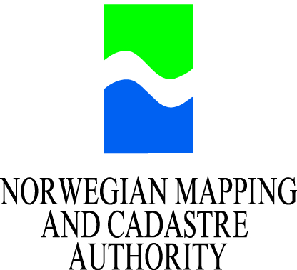
© Norwegian Mapping and Cadastre Authority, 2009.
As a result of this increased use the Mapping Authority also experienced increasing system breakdowns, since the IT infrastructure could not cope with the large amount of information that was requested. To cope with the growing demand for its services the Mapping Authority therefore had to decide whether they wanted to purchase additional software licenses or to become independent from proprietary licenses and to invest in alternative open source infrastructure. After thorough consideration, the team finally decided to run both, the proprietary and the open source systems in parallel, in order to test the capabilities of the open source infrastructure. The results of this test provided evidence that the open source infrastructure was not only considerably cheaper, but that it was also much more reliable, and gave them independence from a vendor.

Organisation and background
The Norwegian National Mapping Authority is Norway's main organisation when it comes to the collection and distribution of geographic information and mapping material. About 50 percent of the work at the Mapping Authority focuses on the operational and distributional services and mechanisms, serving the Fishing department and other official departments in Norway. The other 50 percent of their work relate mostly to standards, such as ISO, in order to assure that the Mapping Authority's output complies with other organisations and agreed standards.
In January 2005, about 600 organisations and partners came together to form the 'Noway Digital' initiative. “'Norway Digital' is a nation-wide program for co-operation on establishment, maintenance and distribution of digital geographic data. The aim is to enhance the availability and use of quality geographic information among a broad range of users, primarily in the public sector”. Erland Røed, department manager at the Mapping Authority, further elaborates: “[...] all the municipal authorities, directorates, ministries, the police, or the armed forces are collaborating in the Norway Digital collaboration. The principle there is that one signs an agreement stating that 'I will take part and offer all my data to the collaboration'. And thus one gets access to all the other partners' data.” By sharing all the information collected by the various partners, the allocation of data has become much more efficient and the data range much more extensive. This also explains the need of standard compliance, as all the partners have to be able to access and use the information that is being provided amongst the partnership.
Through the participation in Norway Digital, the amount of WMS (Web Map Services) requests has increased dramatically. Where in 2007 already about 50.000 map images were requested on an average day, this has increased to roughly 300.000 in 2009, tendency rising.

Budget and Funding
Erland Røed. Department manager at the Norwegian Mapping Authority © Erland Røed, 2009.
The Norwegian Mapping Authority is funded by the national government of Norway. Although there is no dedicated budget for the IT infrastructure, as the main priority is to have an efficient and functioning system, the national government encourages publicly funded bodies to reduce IT costs by using free and open software, where this is possible.
In the years before 2007, the Mapping Authority paid annual licensing fees to the software provider ESRI. These were relatively expensive and with the increasing amount of data requests, the Mapping Authority either had to purchase additional licenses or had to find more economical solutions, which would cope with the requirements equally well and would not undermine the quality of services provided. With an eye on the future, the team in charge of the IT infrastructure at the Mapping Authority realized that the financial burden of this would eventually become larger and larger. “To keep up with the escalation of use, we would have to buy even more licenses” says Røed.
In late 2007 the team started to implement an infrastructure based on open source software in parallel to the proprietary software based one already in place. At first, this was not public and just for internal testing purposes, but after three month of testing the solution went live and replaced the proprietary solution. After a year of use, the team was more than happy to see that they had a stable solution that was not only much better performance-wise, but also much more economic in financial terms. “We estimated that we saved about EUR 250.000 in 2008 by avoiding purchasing additional licenses from ESRI”, highlights Røed. And as the amount of use had steadily increased over the year, this sum would have doubled or even tripled in 2009, Røed further states.
Of course the Mapping Authority also had to make some investments for the new infrastructure. Especially the building up of in-house expertise was essential for this project, as there was no more any external service provider who the team could contact if there was a problem. The Mapping Authority therefore hired a new member of staff to fill this skill gap. In addition, the team that has been involved in the project was sent to conferences and learning workshops, in order to strengthen the knowledge within the whole team. Even though this involved some financial investments as well, the amount of money spent on this was considerably lower compared to the software licenses that would have had to be purchased if the team would have decided to stay with the proprietary solution.

Technical issues
The main task of the Mapping Authority is to provide maps whenever a partner organisation needs one. This process is largely automated, so all requests happen online through the database system. The Mapping Authority does not only have to provide the map, but also complementary information requested by the respective partners. Those complementary information might be the location of ships, weather circumstances, or national preservation areas, for example. At this point, the Mapping Authority has around 300.000 map images per day serving different users and different applications that are run by the partners. “For a small country like Norway that is pretty much”, indicated Røed, with a hint of pride in his voice. On top of the WMS (Web Map Service) that are being used most frequently by the partners, the Mapping Authority also enabled its partners to access maps based on tiles, such as Google Maps, which speeds up the process of accessing information significantly.
To do all this, the Mapping Authority clearly has to have an IT infrastructure that is efficient with resources and reliable, as some of the information may be of crucial importance to some of the partners. The system that had been used until 2007 was based on ArcSDE and ArcIMS, which are both from ESRI. The main problem with this system was, that it had frequent breakdowns and generally was not able to cope with the increasing use. So, for the Mapping Authority “It was either doubling the number of licenses for ArcIMS or to abandon it and replacing it by free and open source software”, recalls Røed.
Corresponding to this situation, the team chose to employ Linux RedHat and several other open source products, such as PostgreSQL, PostGIS, and Mapserver. The BAAT in the following chart stands for user (B), authorisation (A), authentication (A), and counting (T). The system allows the Mapping Authority to give the right information to the right partner, and to control system resources efficiently.
Server infrastructure at the Norwegian Mapping Authority © Norwegian Mapping Authority, 2009.
The system can only be accessed by the member organisations of the Norway Digital co-operation. To make sure that no one else has access to the system, the gatekeepers, which were developed on Tomcat, enable user access control. In a case of an emergency, they also allow the Mapping Authority to give certain partners priority over others, i.e. when a ship is missing and the port authorities have to make full use of the system. The proxies, which are all running on Apache, can be understood as the frontier between the internet and the local network at the Mapping Authority.
On the right side of the chart at the image below, the cache produces the tiles, which is a fast way of presenting maps, as explained earlier. On the left side of the chart, the interceptors check if “you have your ticket”, explains Røed. In other words, they control the user rights one has for the accessing of data. Once user rights have been established, the interceptors allow one to the balancers, which make sure that the Mapserver is not overburdened. The Mapserver then lets one access the maps requested from the database (DB).
With some few exceptions, the system is running almost entirely on open source software. Contrary to many fears, the Mapping Authority has hardly encountered any problems since the infrastructure went live. Considering the breakdowns that were occurring almost on a daily basis with the previous system, this has been a great success for the Mapping Authority. The open source environment manages to cope with the constant increasing of requests seemingly without problems.
The new environment also has an effect on standard compliance. Whereas the ESRI solutions and most other proprietary software only complied with ISO and OGC (Open Geo Consortium) standards to some extent, “the open source software gives the possibility to fulfil the standard 100%” says Røed. By using Web Map Service, which complies with all these standards, the Mapping Authority makes sure that all the other partners in the Norway Digital co-operation can access the mapping images without difficulties. With regard to the functionality, it also brings several advantages, as it entails many useful ways to display mapping images on the Internet. “You can put more or less real time information on top of [the maps], like the AIS [Automatic Identification System] – real time ship traffic, weather information, and other information.”
AIS is a system that allows authorities to track the course, location, speed and possible destination of vessels in coastal waters. Vessels send electronic signals to nearby ships and Vessel Traffic Services (VTS), which allow the transmission of this information. The system relies on location tracking technologies, such as GPS, as well as electronic navigation sensors. As AIS delivers almost real-time data, it helps authorities to avoid collisions, steer rescue missions, and generally control traffic.
The development of an IT infrastructure that allows the Mapping Authority to visualize and store information in real time, such as AIS information, and the collaborative nature of its development may have a broader and longer term implication. The EU has recently adopted a number of regulations (i.e.: "establishing a Community control system for ensuring compliance with the rules of the Common fisheries Policy") related to fisheries management and monitoring which have serious impact on the IT systems of Member States, as new IT solutions need to be implemented to support the above requirements. In this context, the benefits of collaborative systems and the advantages of open source software and developments such as the AIS are already being studied by the European Commission's Directorate General Mare.

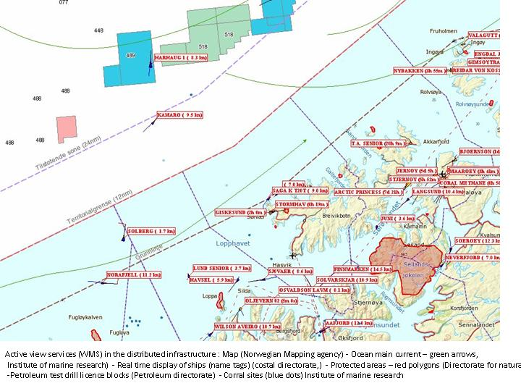Example of a web mapping image as used by the Mapping Authority © Norwegian Mapping Authority, 2009.

Change management
At the start of the project, the Mapping Authority had only little knowledge of open source software environments. Therefore they had to find ways to get acquainted with the new system, while they were still using the old infrastructure. As Røed remembers this process “We didn't have any competence or skills connected to open source software. But we built it up quite fast and then we changed the service, and ran a double operation by having the official deliverance going from the ESRI software, while we tested out the open source software on the side.” Starting in the fall of 2007, the team ran the systems in parallel for about three to four month until they felt that the system was fit for the job, and they had gained the necessary understanding of it.
At the Mapping Authority usually three people dedicate their time to the evaluation and distribution of geographic information and another three people to the technical aspects of the work. For the introduction of the open source environment, both groups “joined forces” and together with a new member of staff who had thorough knowledge of the operating system and general open source working methods, they tweaked the system according to their needs. Røed explains that acquiring knowledge on open source software was at the end rather easy and fast: “We found a lot of material on the internet. There are a large number of communities that can help you a lot and which have already implemented the respective solutions successfully.”
The three most importance improvements for the Mapping Authority are: performance improvement, cost savings, and the freedom to change and adapt the software according to their needs- independent from a software vendor.
With the previous vendor ESRI it was very difficult to add custom system functionalities, it could take weeks to get feedback on a problem or request, and the Mapping Authority could do only little themselves to fix the system. With the introduction of the open source solutions, the team was free to adapt the software to their needs, and they had to find other ways to solve problems. By not relying on a support partner, one has to take responsibility over the system oneself. Although this last aspect may be fearful to some, for the team at the Mapping Authority rather the opposite was the case, as Røed explains: “This sparks the technician's interest. It is a challenge to him; a possibility to have the total responsibility. You can't point to a company and say 'I can't do anything about it, I need support.'” The new system has been an interesting challenge for the people at the Mapping Authority to take the responsibility and to have the freedom to do what they want. “Now we really have the possibility to master the whole thing. And that has been a trigger for our people to do things, to make things work” Røed further adds.

Cooperation with other public bodies and the online community
The Mapping Authority essentially co-operates on two different levels: with regards to the content (i.e. the information for maps) they stand in close collaboration with the partners from the Norway Digital initiative. This however had no impact on the development of the new software environment, as the cooperation mainly aims at establishing a two-way exchange of geographic information. Besides the provision of WMS and other information, the Mapping Authority has shared some of its in-house developments with other partners within the Norway Digital cooperation. Although most of these in-house developments are rather specialized on the needs of the Mapping Authority, other organisations may find themselves in the need of similar solutions. By employing open source solutions, the Mapping Authority had the freedom to share any solution they developed without breaching any license agreements. The government even established the platform Friprog.no for the exchange of information, experience, and code amongst organisations and public bodies in Norway.
With regard to the development of the open source system infrastructure, the Mapping Authority sought the cooperation with the online communities behind the software solutions they employed. In order to gain expertise and a clear understanding of the open source software environments involved they realized that the best way of doing so is by referring to the online communities, such as OpenGeo. Those collaborations were extremely helpful, and eventually became the most important knowledge resource for the team. Compared to the software vendor that in older times would provided guaranteed support, even if delayed, the team at the Mapping Authority initially feared that it might be much harder to rely on the volunteering support provided through the open source software communities on the web. However, contrary to this assumption the Mapping Authority's experiences so far has been rather the opposite. With the software vendor that they had contracted “we had weeks of waiting, in the worst case even a month”, remembers Røed. Now, with the open source solutions, nobody will give you a guarantee that you get an answer, but their experience so far has shown that “there's always someone to ask, and there has always been an answer from somebody.” And, even better, this usually happens within minutes. Consequently, the Mapping Authority advices other institutions to take the risk, as their worst fears of standing alone with a problem have simply not come true.

Evaluation

Achievements / Lessons learned
“We have had only positive experiences with this. It might seem a bit boasting, but we haven't experienced a single setback”, states Røed proudly. The project therefore has been a great success for the Mapping Authority.
As stated before, the three main improvements that the undertaking brought along were: the cost savings, the improved stability, and the freedom to adapt the system to their needs. Considering that the services the Mapping Authority provides are still increasingly requested , these three points gain in importance continuously. Where the savings generated by not having to purchase licenses amounted to EUR 250.000 already in 2008, these may well have been doubled again by the year of 2010. The stability plays an equally important role, as more and more partners relay on the services. By relaying on open source solutions, the Mapping Authority can ensure that system breakdowns do not hinder the work of others.
One more positive aspect of open source solutions is the ability to share developments and expertise. Any developments that the Mapping Authority has done themselves can be shared with others, where this appears useful. The Norwegian government is also trying to promote the use and the sharing of open source software through the portal Friprog.no. Through this portal, the government has released a kind of “cook book”, as Røed explains this, where organisations are guided on their way to implementing open source software.
To conclude, Røed says: “Just try it, that would be my advice.” Although the fear of not having a support partners may be reasonable, the Mapping Authority has not encountered any problems in this respect so far. And even if an organisation is obliged to contract an official support partner, there are plenty of companies offering just this service.

Conclusion
The Mapping Authority's undertaking to deploy open source software in the place of proprietary solutions appears to be a overall a success story. On the one hand the financial benefits are clearly visible, but perhaps more importantly are the performance aspects. With the new infrastructure the Mapping Authority has managed to build up a system that is much more economical and much more reliable than the previous system. This might be one important aspect learned from this case study. A lesson learnt that Røed likes to share with other organizations is: Just try it. As the fear to stand alone without any support often becomes a barrier in the consideration of open source solutions, seeing that it actually can work without much difficulties is an important lesson.

Links
The Norwegian Mapping and Cadastre Authority
The Norway Digital cooperation
Friprog.no
The OpenGeo community website


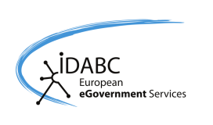

This case study is brought to you by the Open Source Observatory and Repository (OSOR), a project of the European Commission's IDABC project.
Author: Gregor Bierhals, UNU-MERIT
This study is based on an interview with Erland Røed,department manager at the Norwegian Mapping and Cadastre Authority, as well as email exchange with Francky Callewaert from the European Commission. Additional information has been taken from the websites listed in the Links section, as well as further information provided by the Norwegian Mapping and Cadastre Authority.

For a link to the website, please refer to the Links section at the end of this case study.

